Header

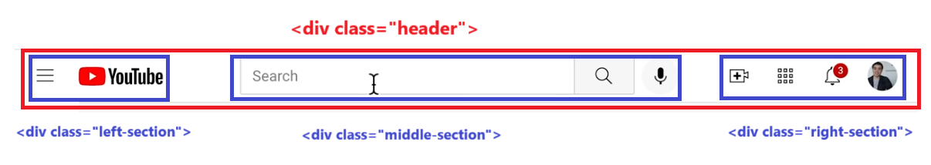

<body>

    <div class="header">

        <div class="left-section">

        Left Section

        </div>

        <div class="mid-section">

        <input class="search-bar" type="text" placeholder="Search" /> //place the search box here

        </div>

        <div class="right-section">

          Right Section

        </div>

    </div>

NOTE : Best practice is segregate the css contents in separate files

To organize all the css create a separate folder by the name **styles** and place all the css files in this folder

Video.css

Header.css

General.css

<link rel="stylesheet" href="./styles/general.css" />

<link rel="stylesheet" href="./styles/header.css" />

<link rel="stylesheet" href="./styles/video.css" />

In the general.css

 body{

    margin:0px

  }

Step 2

.header{

    height:55px;

    display: flex;

    flex-direction: row;

border:1px solid red;

}

.left-section{

background-color: lightblue;

}

.mid-section{

background-color: lightpink;

}

.right-section{

    background-color: lightgray;

}

Step 3: if you observe, the mid section expands and shrinks with the webpage width + it expands to a limit after that the width of the mid section freezes

.mid-section{

background-color: lightpink;

flex:1; // will take up the remainder of the space as the page expands and shrinks

margin-left: 70px;

margin-right: 35px;

max-width: 500px; //will be max max 500

}

.header{

    height:55px;

    display: flex;

    flex-direction: row;

    justify-content: space-between; //spread out the elements evenly

}